**Exploratory Analysis of RainFall Data in India for Agriculture.**

**Team ID: PNT2022TMID14038**

WAY TO INSTALL ANACONDA

STEP 1: Download and Anaconda.

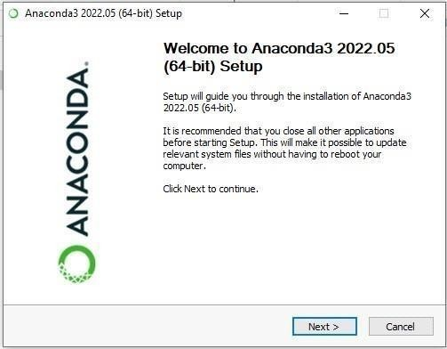STEP 2: Install the Anaconda.

STEP 3: Click I Agree.

STEP 4: Choose the Installation Location.

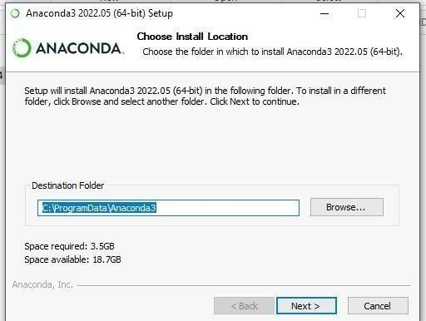

STEP 5: Installing the Requiring packages.

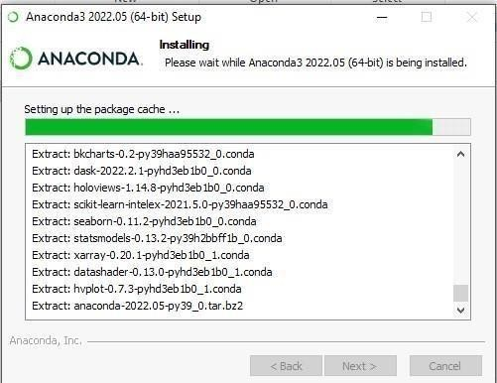

STEP 6: Setting up the base environment.

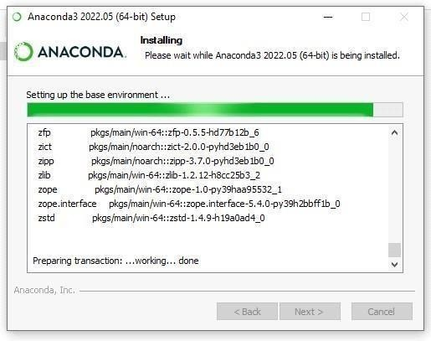

STEP 7: Successfully Installed and check the Anaconda Navigator is working or not.

